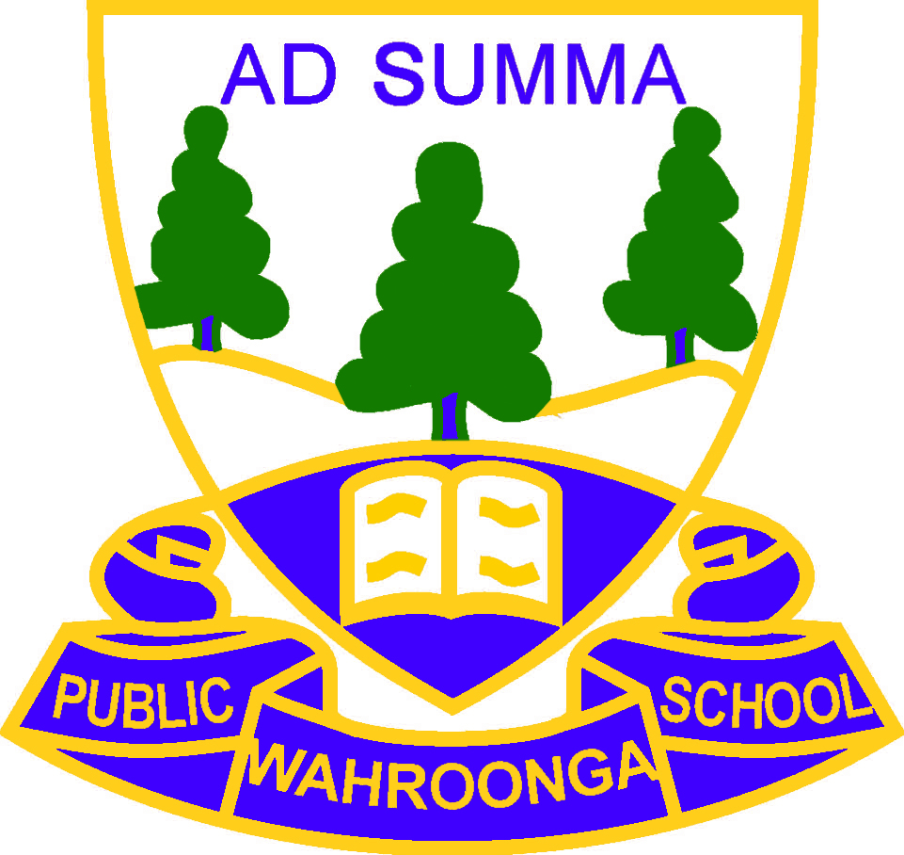 | WAHROONGA PUBLIC SCHOOL  “The Bush School”  Address: 71 Burns Road, Wahroonga NSW 2076  Phone: 9489 3086 | Email: Wahroonga-p.school@det.nsw.edu.au  Website: http://www.wahroonga-p.schools.nsw.edu.au

Dear Parents,

PRE-ORDERING OF UNIFORMS

All students attending Wahroonga Public School are required to wear the school uniform. In terms 1 and 4 this comprises the summer uniform, while the winter uniform is worn in terms 2 and 3.

The P&C provides the school with an on-site uniform shop. All profits raised by the volunteer staffed uniform shop are used by the P&C to improve facilities for children at the school in consultation with school leaders and the membership.

Normally the uniform shop is open one morning and one afternoon during the week. Due to COVID-19 restrictions the uniform shop is currently closed for over the counter sales. All sales at this current time are to be made via our online ordering system www.flexischools.com.au. Simply register as a Wahroonga Public School family in class “Kindy 2021”. Canteen, uniform shop and P&C social events all sell through Flexischools so registering and ordering through there will be the first of its many uses.

Summer uniforms will be available through FlexiSchools from the beginning of term 4 (Monday 12th October). For families new to the school, a basic list of uniform requirements is attached to make ordering simpler. This is a guideline only and you may adjust quantities as desired. Orders will be available for pick up from the school office between 9am-3pm; an email or text message will be sent when the orders are complete. If you find you have ordered the wrong sizes or quantities, items can be returned or exchanged as long as they are in their original condition with tags attached.

If restrictions are eased and normal orientation can proceed, the uniform shop will open for over the counter sales twice per week as well as during the orientation mornings. If restrictions do not ease we are planning to have a ‘pop up’ shop by appointment. Please note that this is yet to be confirmed, further details will be communicated via written means.

At this time FlexiSchools is the only way to purchase school uniforms.

Yours faithfully,

Alysha Allison,
Uniform Shop Manager
Email: bush.uniformshop@gmail.com

How do I register for a Flexischools account?
You can register by following these steps:
- You can access the service at by clicking the "Register Now" button below
- Submit your email address to create an account.
- Go to your Inbox and open the registration email from Flexischools.
- Click on the link provided (or copy and paste the link in a new internet browser window).
- Follow the registration process, creating a password and completing your personal details.
- Add users to your account. This could be your students or yourself if you are a staff member, Alumni or friend of the school.

WAHROONGA PUBLIC SCHOOL
“The Bush School”

Address: 71 Burns Road, Wahroonga NSW 2076
Phone: 9489 3086 | Email: Wahroonga-p.school@det.nsw.edu.au
Website: http://www.wahroonga-p.schools.nsw.edu.au

Basic Uniform Requirements for Summer

Boys
Shorts, grey x 2 pairs
Short sleeved white shirts x 4
Grey ankle socks x 4
School Hat
Sports Shorts
Sports Shirt
Sports socks x 1

Girls
(Girls have the option of summer dress or shorts & shirt, or a combination of both)
Summer dress x 2
Bike shorts x4 (undershorts for under dress)
Shorts, green x 2
Short sleeved white shirt x 4
Bottle green ankle socks x 4 (worn with both the dress and shorts)
School Hat
Sports Shorts or skort
Sports Shirt
Sports socks x 1

Boys & Girls
Back Pack
Chair Bag
Library/ Excursion Bag
Morning Tea Bag x 2
Art Smock

Additional Uniform Items
Sports tracksuit, to be worn on sports days only, if cold
School bomber jacket, fleece jacket or fleece vest, to be worn on other days.

Tracksuits, Jackets and Jumpers can all be bought closer to Term 2, 2020 when the warmer weather subsides.

Wahroonga Public School Summer Uniform Price List, Kindergarten 2021

BOYS |  | GIRLS
Shorts - grey | $25 | Summer Dress | $58
Shirt – short sleeve, white | $25 | Bike Shorts – green, 2 pack | $12
Socks – 2 pack, short, grey | $10 | Shorts – bottle green | tbd (new item)
 |  | Shirt – short sleeve, white | tbd (new item)
 |  | Socks – 2pack, short, green | $12
SPORT |  | UNISEX
Junior sport shirt | $30 | Hat S-55cm, M-57cm, L-61cm | $22
Sports skort/skirt | $26 | Bomber jacket | $45
Sports shorts | $22 | Fleece jacket | $45
Sports socks – 2 pack | $12 | Fleece vest | $28
Tracksuit set (any size combination) | $65
Jacket only | $45 | OTHER
Pants only | $32 | Backpack | $60
 |  | Raincoat – yellow | $35
HAIR ACCESSORIES |  | Art Smock | $20
Hair band – dark green | $11 | Chair bag – denim | $15
Hair band – summer fabric | $12 | Morning tea bag | $3
Hair clips – 4 pack | $5 | Library / Excursion bag | $15
Hair elastics – 4 pack | $5
Ribbon curlies – green & purple | $12
Pigtail bows (2 pack) | $9
Scrunchie – summer fabric | $8 | * Prices subject to change – please refer to Flexischools or instore any changes
Scrunchie – green fabric | $7 | * A range of secondhand items are available instore only

